15.22: 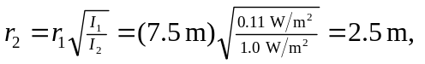so it is possible to move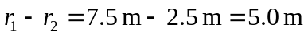closer to the source.

